EX NO:02
EL HORNO'S PIZZA BI ANALYSIS

AIM:
Problem Statement: You have been hired as a BI Analyst by El Horno’s Pizza. The company is trying to assess marketing strategy effectiveness and sales distribution across different products. The Director of the company has asked you to show the following:

- Sales trend across 2 product categories, Pizza and Burger. Build an Area Chart.
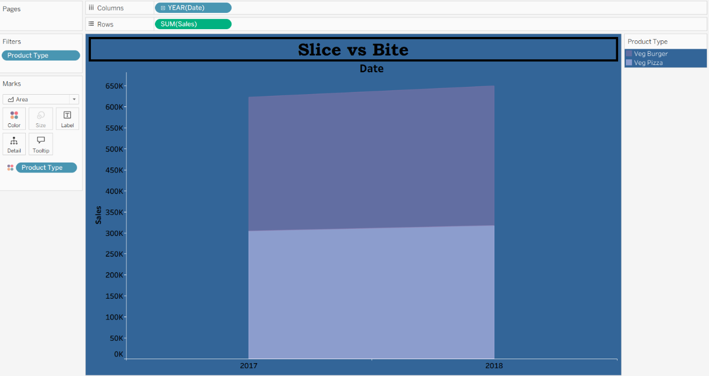
- A Pie Chart and display Total Sales Distribution across product categories.
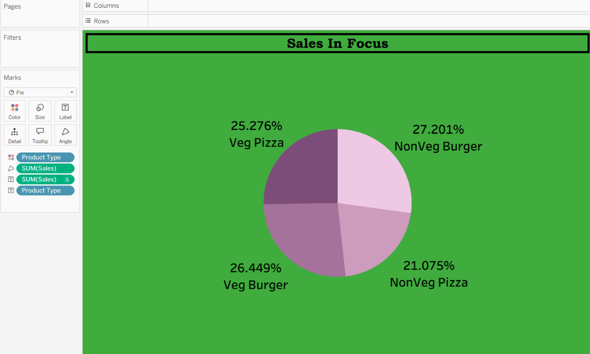
- Sales distribution across product categories. Show a Chart by States which indicates the percentage of Pizza category sales across total sales.
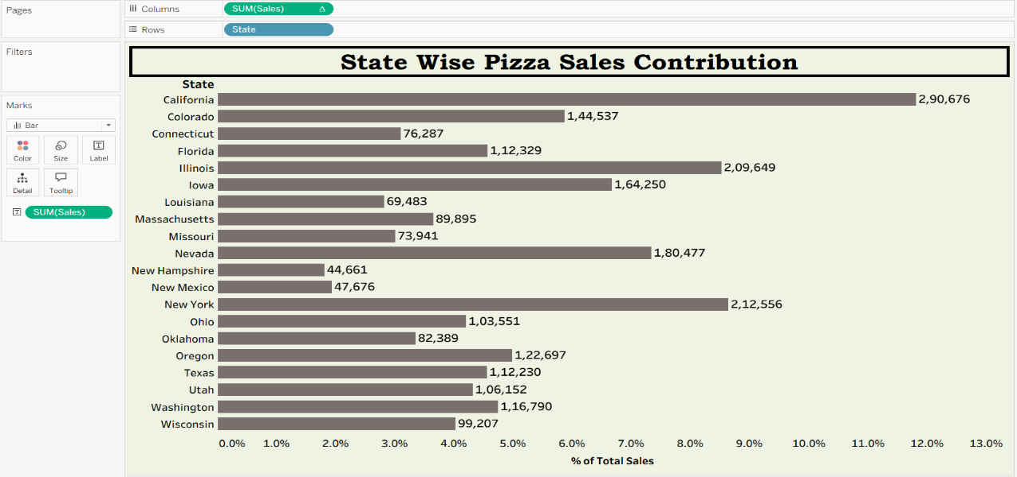
- Sales distribution across product categories. Show a Chart by states which indicates the percentage of Burger category sales across total sales.

- Identify the States, wherein the marketing campaigns are most effective and which of the marketing teams need to revise their tools? Show this on Vertical bar chart.

- A Scatter Plot and identify for correlation between Sales and Marketing Expenses, if any. Through Highlighting feature, identify for any changes within the years.

